TC-AUTH-026
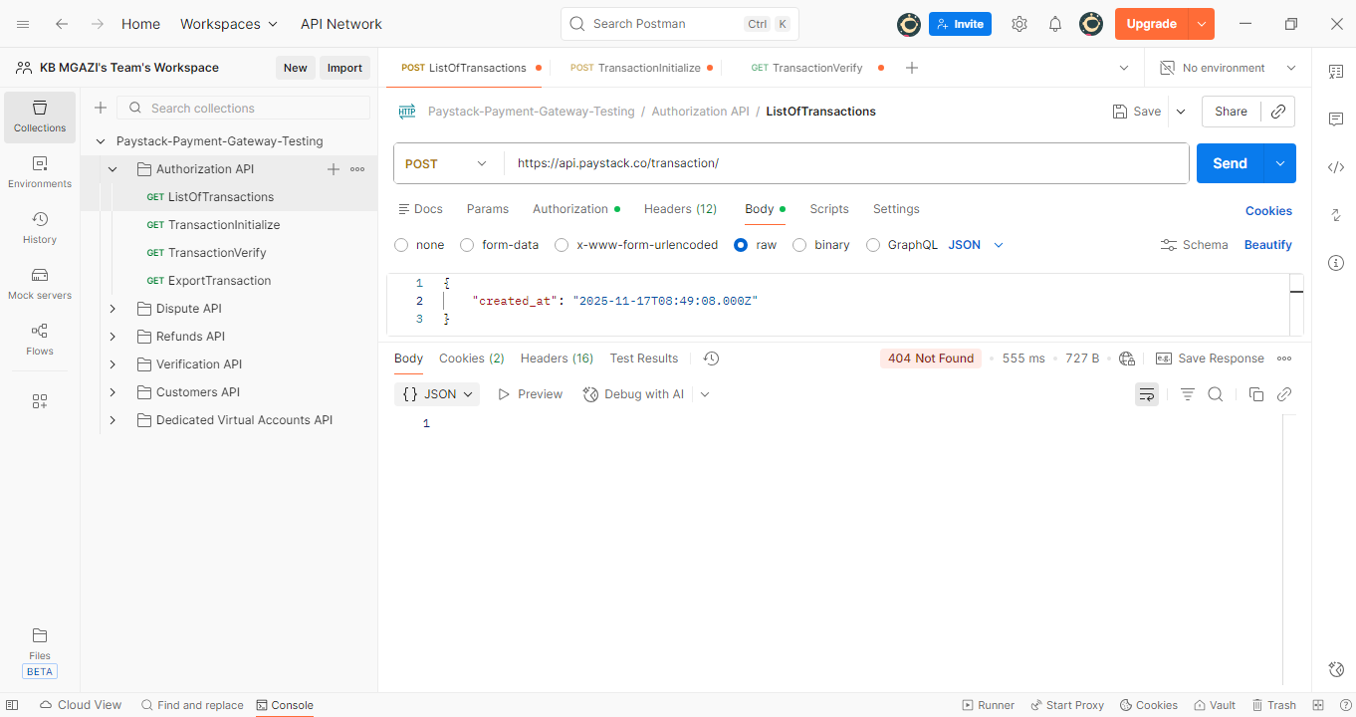
Request:
{
"created_at": "2025-11-17T08:49:08.000Z"
}

Response:
